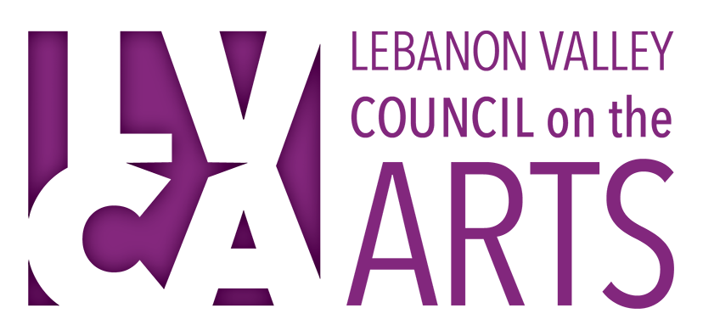
SUMMER 2026 Art Club
Registration Form
Join us for Art Club 2026! These art instruction sessions are designed for Middle School and High School level young people. There is no cost to participate. Supplies will be provided. Students will practice art skills such as sculpting, painting, and sketching. Attendance at every session is preferred, but not required.

Dates: June 15, 16, 17, 18, 19, 2026
Time: Each session begins at 1:30 pm and will end at 3:00 pm
Instructor: Ms. Laura Mechling
Location: Lebanon Valley Council on the Arts 770 Cumberland St Lebanon PA 17042

- Registration will be on a first come, first served basis.
- Please let us know if you intend to cancel at least one week prior to the start of camp. Email lebanonartscouncil@gmail.com of your intent to cancel.
- Participants are encouraged to act appropriately and avoid bullying or other negative behavior.

This opportunity is funded by the Arts For All Grant of The Foundation for Enhancing Communities. With additional funding from Mt Gretna United Methodist Drendall Endowment, and Sandy Hollow Arts and Recreation for the Environment grant

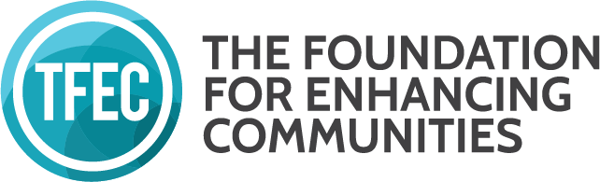

PARTICIPANT INFORMATION
First and Last Name: Age:
Address:

School:
Emergency Contact:
Phone Email:
PARENT/GUARDIAN INFORMATION
Parent/Guardian’s Name:
Address:
Phone: Email:
REGISTRATION AGREEMENT
I give my permission for my child to walk/bike home daily. YES NO
( circle one.)
Child will be picked up by:
(Person other than parent/guardian.)
NOTE: Children must be picked up no later than 15 minutes beyond the end of each day.

Does your child have allergies, special concerns, or medical/mental health conditions we should be aware of? YES NO
Please list and describe: ______________________________________________________________________

______________________________________________________________________
- I allow my child to participate in any promotional pictures from the event.
- I allow my child to visit buildings of architectural interest in the Lebanon area.
- I allow the instructor to call 911 in the event of an emergency, and I cannot be reached.
On behalf of my child and for myself, I knowingly assume all risks arising from participation in activities related to the event.

Signature: __________________________________________ Date: ____________
Return this form to register. Email at lebanonartscouncil@gmail.com Or, mail to LVCA 770 Cumberland St., Lebanon, PA 17042. Questions, leave message at 717-273-0033

